The Relationship between Employment in the Agricultural Sector and Gross Domestic Product

Vidhur Potluri

Texas A&M University

ECMT 463 Research Paper

Vidhur.potluri@tamu.edu

Abstract

Reallocation of a country’s resources to increase industrial production or improve its service sector is generally accompanied by economic development. This paper analyzes the effects of the changes in employment in the agriculture sector (as a percentage of total employment) on the gross domestic product of a country. This study analyzes data from the past 25 years and has been sourced from every country in the world where this data is available. This study conducts a regression analysis and finds a negative causal relationship between employment in the agricultural sector and the GDP of a country. It concludes by noting the benefits and disadvantages of a declining agricultural sector.

Keywords: *GDP per capita, Employment, Agricultural Sector*

THE RELATIONSHIP BETWEEN EMPLOYEMENT IN THE AGRICULTURAL SECTOR AND GROSS DOMESTIC PRODUCT

Efficient allocation of resources is necessary for economic development. A nation’s scarce resources coupled with its citizens’ constantly changing needs and wants define how its resources are allocated. In the past, a country’s agricultural produce and work force were the most significant contributors to its gross domestic product. Between 1991and 2017, the share of employment in services has risen from 33.68% to 51.09%, whereas the share of employment in agriculture has dropped from 43.25% to 26.47%[1]. The changing needs of people and the advancement of technology gave way to a large manufacturing and even larger service sector. Countries are allocating their resources accordingly by withdrawing investments in the most primitive of these sectors. The most valuable of these investments is labor. With the expansion of Research and Development (R&D) programs and increasing demand for new technology, many people are unwilling or unable to sustain a livelihood working in the agricultural sector despite the increase in population. Agricultural sector includes agriculture, hunting, forestry and fishing.

The agricultural sector’s contribution to the GDP (as a percentage) is decreasing with the expansion of the other two sectors. As of 2010, in countries with a GDP per capita over 15,000 international dollars, less than 10% of the economic output occurs in the agricultural sector1. This decline and its relation with GDP (not discussed in this paper) are obvious causes of the decline in employment in that sector. Since agricultural products have a low-income elasticity[2] of demand ((less than 1), the demand for these products have not grown proportional to the substantial growth of gross nation income per capita of most countries. However, these agricultural products still have a high demand since they are essential to every human being. Moreover, the agricultural sector still provides a livelihood to a significant percentage (26.9% according to the World Bank) of the world’s population. Better technology might be able to replace those dependent on agriculture (decrease in employment) and produce a higher yield, but this would also increase unemployment, which is a deterrent to economic development.

This paper explores the relationship between employment in the agricultural sector (as a percentage of total employment) and the Gross Domestic Product per capita, PPP (constant 2011 international $). Characterizing the GDP by PPP (Purchasing Power Parities) and using constant 2011 international dollars help account for inflation and the different purchasing powers in different countries since the data comes from many countries and over a time-span of 25 years. The research behind this study leads to the hypothesis that a decline of human resources allocated to the field of agriculture is correlated with a higher GDP of a country and economic growth. The literature review that follows will help us understand the importance of the regression analysis that follows.

# Literature Review

**The role of the agricultural sector in a growing economy**

Tsakok and Gardner (2007) discuss how the agricultural sectors of different countries affected their economic growth. They explain that since poor countries have a high population involved in agriculture and there is a high amount of food consumption in these countries, high levels of income can only be generated through agriculture. But they also mention that the poor would be benefitted more if a given amount of the GDP is produced by the industries and service sector. Agricultural products are used heavily in the industrial sector, and indirectly cause economic growth. However, the paper does not comment on the relationship between employment and labor productivity in the agricultural sector which is a necessary factor in the debate of whether or not employment in the agricultural sector and GDP growth are correlated. This paper will be testing whether poor or underdeveloped countries experience economic growth through higher agricultural labor productivity and employment.

Rostow (1960) defines and describes the stages of economic growth of a country: 1) the traditional society, 2) the preconditions for take-off, 3) the take-off, 4) the drive to maturity, 5) the age of high-mass consumption. He declares that the agricultural sector is important in the first three stages, and begins to decline from the fourth. He defines traditional society as “the whole pre-Newtonian world: the dynasties in China; the civilization of the Middle East and the Mediterranean; the world of medieval Europe” (pg 5). The preconditions for take-off were established during the late 17th century and the early 18th century. Since data on employment share in agriculture and GDP per capita is only available since 1960, this paper tests Rostow’s arguments regarding the significance of the agricultural sector during the different stages of economic growth from the 3rd stage i.e., the take-off.

### **Causes of decline in employment in the agricultural sector**

Annemarie (2015) discusses in her paper that the total employment in the agricultural sector is high but decreases rapidly with economic growth in developing countries while it is low but stable in developed countries. To test this, she takes the countries of Indonesia, China, the Netherlands, and the USA as case studies. Using data from the World Bank, she shows evidence of a decrease in share of agriculture in the GDP and share of agriculture in employment (as a percentage) for each of the countries, while this decrease is lower in USA and the Netherlands. To discuss her findings and pinpoint the cause of the changes in employment share, she uses three main factors which are discussed below–

1. The ratio between agricultural labor productivity and total labor productivity: The employment in the agricultural sector will decrease with an increase in agricultural labor productivity. Compared to other sectors, the labor productivity in agriculture will grow at a higher pace because of adaptation of new technology and R&D undertaken by Governments. The availability of credit and high-income levels in developed countries causes the adaptation of new technology to be higher there.
2. Share of value of agricultural productivity in total value of production: In a growing economy, the total production from all sectors grows faster than food production, lowering the price of agricultural products and thus, lowering employment share in agriculture.
3. The ratio of total prices and agricultural prices: Since the demand for agricultural products is inelastic, production of these products grows at a pace higher than the demand. This causes a lower share for agricultural prices compared to total prices. She argues that this is the only factor that increases the share of employment in agriculture.

Annemarie (2015) concludes by saying that the leading cause of the decreasing share in employment in the agricultural sector in countries across the globe is the increase of agricultural productivity. The share of employment in the developing countries – China and Indonesia – went from 55% to 38% and 65% to 28% respectively between 1989 and 2010. This is a significant change. The shift in employment was not as significant in USA and the Netherlands – employment share in agriculture stayed between 2% and 5%. The data supports the causes she listed.

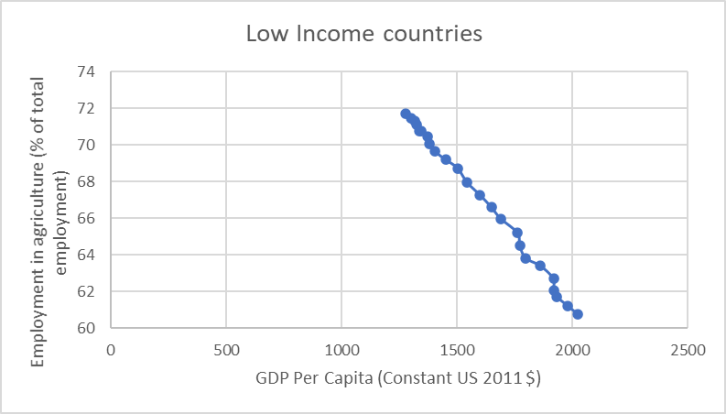  
Graph 1

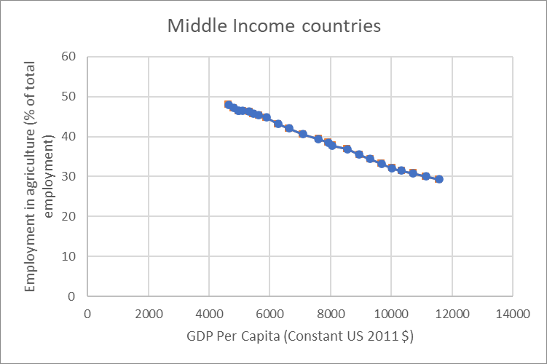  
Graph 2

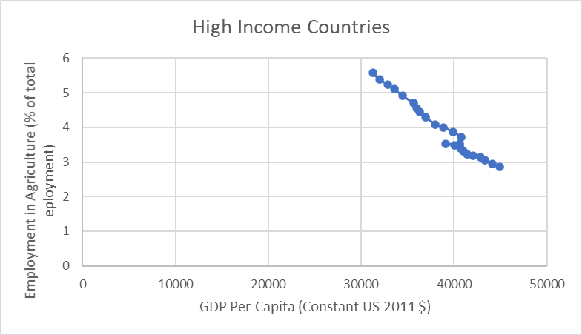  
Graph 3

The source for the data for these graphs is the World Bank. The graphs show the average GDP and employment percentage of the several countries in those categories over the years 1995 – 2018.The 3 graphs show that highly developed countries tend to have low levels of population employed in agriculture and the rate of decrease in employment as GDP increases is also lower than poorer countries (low income and middle income).

# Data

I chose to include those variables that are essential to the economic growth and those which do not create a biased regression or perfect multicollinearity. The source for all the variables’ data is the World Bank’s data catalog. The data comes from the years 1995 – 2018 and from 217 countries where the data is available. The values of the variables are averages of the 217 countries. These variables are described in table 1.

Table 1

Variable description and sources

| Variable name | Unit |
| --- | --- |
| GDP  AgriE | Constant US 2011 dollars  % of total employment |
| Pop | Number; Average of all countries |
| Capital  Indu | % of GDP  Constant US 2010 dollars |

1. GDP: GDP per capita (PPP) is aggregated from all the countries where the data is available (Dependent variable)
2. AgriE: The employment share in agriculture as a percentage of the total employment. (Independent variable) This is our main independent variable whose significance we are trying to calculate through regression analysis.
3. Pop: The average population of a country in the world at the given time. It is an essential factor when considering economic growth especially since we are using the GDP per capita as our dependent variable.
4. Capital: Gross Capital formation as a percentage of the GDP. Capital formation is an important factor to economic growth because of the significance of infrastructure, and other investments in the economy.
5. Indu: The value added by Industry (including construction). Infrastructure and manufacturing industries such as roads, factories, etc. are an important source of income of the country.

Pop, Capital, and Indu are the main control variables. These variables will be used to perform linear regressions on multiple regressors (OLS). The first regression equation (I) is –

$$GDP= β_{0}+β_{1}AgriE+u$$

$$H_{0}:β_{1}=0 (The coefficeient of AgriE is 0)$$

$$H_{a}:β_{1}≠0$$

This is a simple OLS regression that checks the effect of employment share in agriculture on the GDP regardless of income levels. The summary of all data is displayed in table 2. The regression data is displayed in table 3.

The second regression equation (II) with the control variables is –

$$GDP= β_{0}+β_{1}AgriE+β_{2}Pop+β_{3}Capital+β_{4}Indu+u$$

$$H_{0}:β_{1}=0 (The coefficeient of AgriE is 0)$$

$$H_{a}:β_{1}≠0$$

Table 2

Summary statistics

|  | GDP | AgriE | Pop | Capital | Indu |
| --- | --- | --- | --- | --- | --- |
| Mean | 12308.48814 | 35.06713996 | 30610909.52 | 23.69255716 | 26072.55426 |
| Standard Deviation | 2091.086596 | 4.750296449 | 2661775.257 | 0.410110575 | 2572.455598 |
| Minimum | 9271.36499 | 27.26610274 | 26301995.5 | 22.98629809 | 19531.61608 |
| Maximum | 15956.6992 | 41.25602104 | 34996637.59 | 24.64907907 | 30424.18683 |
| Count | 24 | 24 | 24 | 24 | 24 |
|  | GDP | AgriE (%) | Pop | Capital (%) | Indu |

As discussed earlier, the paper hypothesizes a negative causal relationship between GDP and employment share in agriculture. Therefore, the sign on $β_{1}$ is predicted to be negative. Since the GDP is being measured per capita, the results of the regression could be heavily biased by not using the population as a control variable. Since human resources contribute to the GDP growth, it is an essential factor and omitting it would cause biased results. The sign on $β_{2}$ is predicted to be positive. Economic growth increases the spending capacity of a country. This increased spending power and disposable resources could be used to invest in capital for further growth creating a cycle. All countries interested in a higher GDP tend to increase their investment capitals. By including the capital variable, I eliminate the bias created by disregarding a major portion of the economy. Hence, the sign on $β_{3}$ is also predicted to be positive. As discussed earlier, the decrease in the share of a country’s resources in the agricultural sector means an increase in the other sectors. Many poor countries lack a service sector but all countries have an industrial sector. This is why a service sector variable hasn’t been included but the industry variable is included to emphasize and understand the significance of the shift in resources. The exclusion of the service sector also helps avoid collinearity. The sign on the coefficient of indu is predicted to be positive.

A t-test will be used to determine the significance of AgriE at the 90%, 95%, and 99% confidence levels. The regression was conducted using Microsoft excel. There was no need to introduce any dummy variables or interaction terms.

**Results**

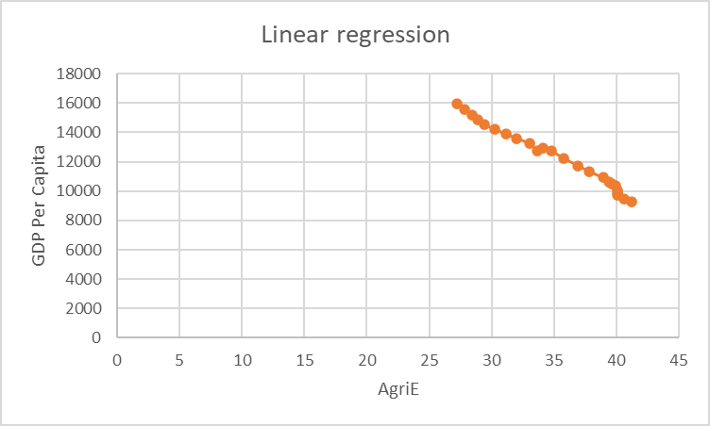

Graph 4

Graph 4 depicts the relationship between GDP Per Capita (dependent) and employment (independent0 in agriculture. The relationship is approximately linear and negative. A decrease in the employment share in agriculture is consistent with an increase in the GDP per capita of a country. The control variables are omitted from the graph.

Table 3

Regression results

| GDP | (I) | (II) |
| --- | --- | --- |
| AgriE | -437.343  (10.67798) | -147.096  (34.07085) |
|  |  |  |
| Pop |  | 0.000545  (7.02E-05) |
|  |  |  |
| Capital |  | 210.6576  (54.49447) |
| Indu |  | -0.02551  (0.018435) |
| Intercept  Observations | 27644.85  (377.7245)  24 | -3541.54  (3544.508)  24 |
| R square | 0.987055 | 0.998005 |

Although the observations are noted as 24, the actual data comes from 217 countries over the timespan of 24 years. As predicted, the sign on $β_{1}$ is negative in both models. The calculated ‘t-statistics for $β_{1}$ is -4.31736 in model II. The first model that disregards the control variables leads to extremely biased results. The t-statistic for model I is -40.9574306 and inaccurate.

Therefore, a 1 unit increase in AgriE leads to a decrease of 147.096 units of GDP. Using the t-statistic from model I, we can reject the null hypothesis since -4.31736 < -2.58 < -1.96 < -1.64. Therefore, AgriE is significant to the growth of GDP at the 1%, 5%, and 10% levels. The coefficient on AgriE changes drastically because pop, Indu, and Capital are important factors when calculating GDP.

**Conclusion**

While it has been found that a decline in employment in the agricultural sector coincides with an increase in GDP per capita of a country in general, the relationship between the two variables depends on certain other factors. A poorer country experiences rapid economic growth when it allocates more of its human resources in the other sectors, but only when there is an increase in agricultural labor productivity. A developed country tends to achieve economic growth by focusing mainly on their service sector. The employment in its agricultural sector is already low but stable.

The results from our analysis point towards a causal relationship between agricultural employment and GDP. However, the two could be influenced by the same factors such as income levels in the different sectors, decline in agricultural resources, etc. Since agricultural products will always be essential to mankind and economic growth will remain society’s goal, this paper’s discussion and results will always be relevant. This paper discusses the pros and cons of a declining agricultural sector – a debate that most Governments must partake in to ensure the welfare of its citizens.

References

1. “Employment in Agriculture (% of Total Employment) (Modeled ILO Estimate).” Data, data.worldbank.org/indicator/sl.agr.empl.zs.
2. “Data Catalog: Data Catalog.” *Data Catalog | Data Catalog*, datacatalog.worldbank.org/.
3. Max Roser (2020) - "Employment in Agriculture". Published online at OurWorldInData.org. Retrieved from: 'https://ourworldindata.org/employment-in-agriculture' [Online Resource]
4. Tsakok, Isabelle & Gardner, Bruce. (2007). Agriculture in Economic Development: Primary Engine of Growth or Chicken and Egg?. American Journal of Agricultural Economics. 89. 1145-1151. 10.1111/j.1467-8276.2007.01075.x.
5. Annemarie van Arendonk. The Development of the Share of Agriculture in GDP and Employment. May 2015, pdfs.semanticscholar.org/263b/17e0e3c6c9b7e7a156ec2a138fe6955bbf91.pdf.
6. W, Rostow W. *The Stages of Economic Growth*. 1960, cia.gov/library/readingroom/docs/CIA-RDP78-03062A001100030001-6.pdf.

1. Max Roser (2020) - "Employment in Agriculture". Published online at OurWorldInData.org. Retrieved from: 'https://ourworldindata.org/employment-in-agriculture' [Online Resource]
2.